Unit 3 – Lesson 8. Building a SMS App (Part 1)
Aim:
- How do we build an Android app to send and receive and auto-respond SMS?

Objectives: After the lesson, students will be able to:
- Build a SMS app using the knowledges learned in the previous lessons

Source and Reference:
https://www.androstock.com/tutorials/create-a-sms-app-in-android-android-studio-part-1.html

CLASS PROCEDURE:

Do Now:
Go to the Google Play store, and search for SMS apps. You can find lots of them! What functions are you looking for in a SMS app?

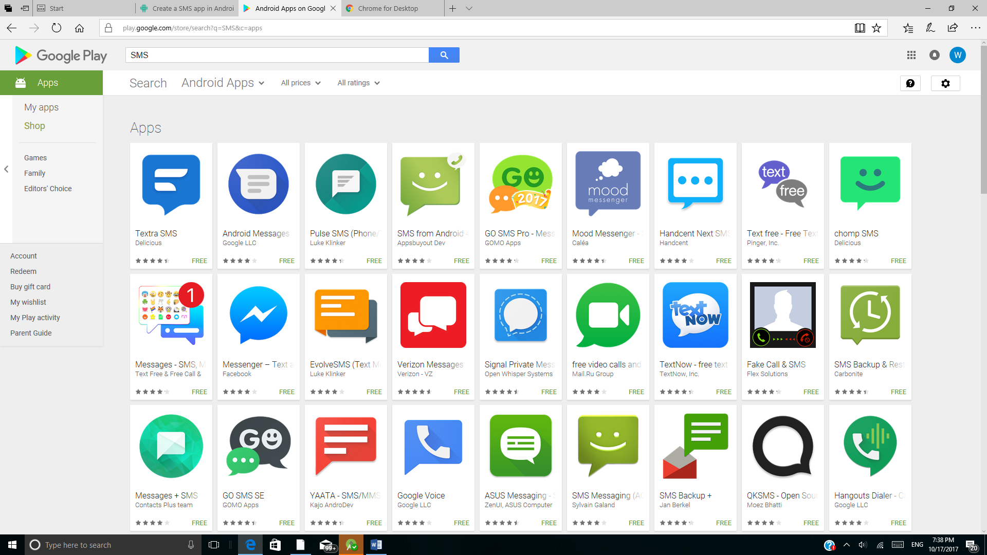

Class Discussions:
- What are the components of a SMS app?

- How do we receive and send SMS messages programmatically?

- We often see the word apk. What is apk for android?

- Just like Windows (PC) systems use an .exe file for installing software, Android does the same. An APK file is the file format used for installing software on the Android operating system.

- We have been seeing the word Gradle very often in Android Development. What is Gradle?

- In Android Studio, Gradle is a custom build tool used to build android packages (apk files) by managing dependencies and providing custom build logic. APK file (Android Application package) is a specially formatted zip file which contains. Byte code. Resources (images, UI, xml etc)

Pair – sharing Activity (We borrowed the contents from a nice online tutorial and the link is on the top of this page):

1. Add the dependencies into your app-level build.gradle file:
compile 'com.android.support:design:26.+'
compile 'com.amulyakhare:com.amulyakhare.textdrawable:1.0.1'
compile 'com.lifeofcoding:cacheutilslibrary:1.1.0@aar'
compile 'com.google.code.gson:gson:2.2.2'
compile 'commons-io:commons-io:2.4'
After syncing your project if any error occurs add these packageOptions into the android section of your app-level build.gradle file:
android {
...
...
packagingOptions {
exclude 'META-INF/DEPENDENCIES'
exclude 'META-INF/NOTICE'
exclude 'META-INF/LICENSE'
exclude 'META-INF/LICENSE.txt'
exclude 'META-INF/NOTICE.txt'
exclude 'META-INF/ASL2.0'
exclude 'META-INF/MANIFEST.MF'
}
}
Now we can start to build the app!
1. Open your AndroidManifest.xml file and add READ_SMS, SEND_SMS, RECEIVE_SMS, READ_CONTACTS, WRITE_CONTACTS permission. Your manifest file will look like this-
<?xml version="1.0" encoding="utf-8"?>
<manifest xmlns:android="http://schemas.android.com/apk/res/android"
package="com.androstock.smsapp">

<uses-permission android:name="android.permission.READ_SMS" />
<uses-permission android:name="android.permission.SEND_SMS" />
<uses-permission android:name="android.permission.RECEIVE_SMS" />
<uses-permission android:name="android.permission.READ_CONTACTS" />
<uses-permission android:name="android.permission.WRITE_CONTACTS" />

<application
android:allowBackup="true"
android:icon="@mipmap/ic_launcher"
android:label="@string/app_name"
android:roundIcon="@mipmap/ic_launcher_round"
android:supportsRtl="true"
android:theme="@style/AppTheme">
<activity android:name=".MainActivity">
<intent-filter>
<action android:name="android.intent.action.MAIN" />
<category android:name="android.intent.category.LAUNCHER" />
</intent-filter>
</activity>
<activity android:name=".NewSmsActivity"/>
<activity android:name=".Chat"/>
</application>

</manifest>
There are total 3 activities declared into manifest. We will build them leter.
2. Open your activity_main.xml file. Use a RelativeLayout to arrange the listviews and FAB buttons. You can adjust the FAB button size to suit various devices.
<?xml version="1.0" encoding="utf-8"?>
<RelativeLayout xmlns:android="http://schemas.android.com/apk/res/android"
xmlns:app="http://schemas.android.com/apk/res-auto"
xmlns:tools="http://schemas.android.com/tools"
android:layout_width="match_parent"
android:layout_height="match_parent">

<FrameLayout
android:id="@+id/bottomViewSearch"
android:layout_width="match_parent"
android:layout_height="match_parent"
android:orientation="horizontal"
android:gravity="center">

<ListView
android:id="@+id/listView"
android:layout_width="match_parent"
android:layout_height="match_parent"/>

<android.support.design.widget.FloatingActionButton
android:id="@+id/fab_new"
android:layout_width="wrap_content"
android:layout_height="wrap_content"
android:layout_gravity="bottom|right"
android:layout_margin="20dp"
android:layout_marginBottom="8dp"
android:layout_marginRight="8dp"
android:descendantFocusability="blocksDescendants"
android:src="@drawable/ic_action_message" />

<ProgressBar
android:id="@+id/loader"
android:layout_width="wrap_content"
android:layout_height="wrap_content"
android:layout_gravity="center"/>
</FrameLayout>
</RelativeLayout>
You can find the Image Resources into the attached project file.
https://www.androstock.com/tutorials/create-a-sms-app-in-android-android-studio-part-1.html

3. Now create a new layout resource file named “conversation_list_item.xml” and paste the below code:
<?xml version="1.0" encoding="utf-8"?>
<LinearLayout xmlns:android="http://schemas.android.com/apk/res/android"
xmlns:customAttrs="http://schemas.android.com/apk/res-auto"
android:layout_width="match_parent"
android:layout_height="wrap_content"
android:weightSum="1"
android:descendantFocusability="blocksDescendants"
android:padding="5dp"
>

<LinearLayout
android:layout_width="100dp"
android:layout_height="wrap_content"
android:gravity="center"
android:orientation="vertical">

<ImageView
android:id="@+id/inbox_thumb"
android:layout_width="50dp"
android:layout_height="50dp"
android:src="@mipmap/ic_launcher"/>

</LinearLayout>

<LinearLayout
android:layout_width="0dp"
android:layout_height="wrap_content"
android:layout_weight="1"
android:gravity="left"
android:orientation="vertical">

<TextView
android:id="@+id/inbox_user"
android:layout_width="wrap_content"
android:layout_height="wrap_content"
android:visibility="visible"
android:textColor="#000000"
android:text="255 sms"
android:textStyle="bold"
android:ellipsize="end"
android:maxLines="1"
android:textSize="16sp"/>

<TextView
android:id="@+id/inbox_msg"
android:layout_width="wrap_content"
android:layout_height="wrap_content"
android:visibility="visible"
android:textColor="#666666"
android:text="255 sms"
android:ellipsize="end"
android:maxLines="1"
android:textSize="14sp"/>

<TextView
android:id="@+id/inbox_date"
android:layout_width="wrap_content"
android:layout_height="wrap_content"
android:visibility="visible"
android:textColor="#888888"
android:text="255 sms"
android:ellipsize="end"
android:maxLines="1"
android:textSize="12sp"/>

</LinearLayout>
</LinearLayout>

4. Create “activity_chat.xml” and use the below codes
<?xml version="1.0" encoding="utf-8"?>
<LinearLayout xmlns:android="http://schemas.android.com/apk/res/android"
xmlns:tools="http://schemas.android.com/tools"
android:layout_width="match_parent"
android:layout_height="match_parent"
xmlns:app="http://schemas.android.com/apk/res-auto"
android:orientation="vertical">

<LinearLayout android:layout_width="match_parent"
android:layout_height="match_parent"
android:orientation="vertical">

<ListView
android:id ="@+id/listView"
android:layout_weight="100"
android:layout_width="match_parent"
android:layout_height="0dp"
android:divider="@null"
android:stackFromBottom="true"
android:transcriptMode="alwaysScroll"
/>
<View
android:layout_width="match_parent"
android:layout_height="1dp"
android:background="#E0E0E0"/>
<LinearLayout
android:id="@+id/llMsgCompose"
android:layout_width="fill_parent"
android:layout_height="40dp"
android:background="#ffffff"
android:orientation="horizontal"
android:weightSum="1" >

<EditText
android:id="@+id/new_message"
android:layout_width="match_parent"
android:layout_height="match_parent"
android:layout_weight="1"
android:background="#FFFFFF"
android:textColor="#666666"
android:paddingLeft="6dp"
android:paddingRight="6dp"/>

<!--<Button
android:id="@+id/send_message"
android:layout_width="0dp"
android:layout_height="wrap_content"
android:layout_weight="1"
android:background="#3F51B5"
android:textColor="@color/white"
android:text="SEND" />-->

<ImageButton
android:id="@+id/send_message"
android:layout_width="80dp"
android:layout_height="match_parent"
android:layout_weight="1"
android:src="@drawable/ic_send"
android:background="#3F51B5"/>
</LinearLayout>

</LinearLayout>
</LinearLayout>

5. Again we will create a custom item ui. We named it as “chat_item.xml”
<?xml version="1.0" encoding="utf-8"?>
<LinearLayout xmlns:android="http://schemas.android.com/apk/res/android"
android:layout_width="match_parent"
android:layout_height="match_parent"
android:orientation="vertical">

<LinearLayout
android:id="@+id/msgFrom"
android:layout_width="match_parent"
android:layout_height="match_parent"
android:orientation="vertical"
android:paddingBottom="5dp"
android:paddingTop="5dp"
android:paddingLeft="10dp">

<TextView
android:id="@+id/lblMsgFrom"
android:layout_width="wrap_content"
android:layout_height="wrap_content"
android:textSize="12dp"
android:textColor="#777777"
android:textStyle="italic"
android:padding="5dp"/>

<TextView
android:id="@+id/txtMsgFrom"
android:layout_width="wrap_content"
android:layout_height="wrap_content"
android:textSize="16dp"
android:layout_marginRight="80dp"
android:textColor="#434343"
android:paddingLeft="10dp"
android:paddingRight="10dp"
android:paddingTop="5dp"
android:paddingBottom="5dp"
android:background="@drawable/bg_msg_from"/>
<TextView
android:id="@+id/timeMsgFrom"
android:layout_width="wrap_content"
android:layout_height="wrap_content"
android:textSize="10dp"
android:textColor="#999999"
android:textStyle="italic"
android:padding="5dp"/>

</LinearLayout>

<LinearLayout
android:id="@+id/msgYou"
android:layout_width="match_parent"
android:layout_height="match_parent"
android:gravity="right"
android:orientation="vertical"
android:paddingBottom="5dp"
android:paddingRight="10dp"
android:paddingTop="5dp" >

<TextView
android:id="@+id/lblMsgYou"
android:layout_width="wrap_content"
android:layout_height="wrap_content"
android:padding="5dp"
android:textColor="#777777"
android:textSize="12dp"
android:textStyle="italic" />

<TextView
android:id="@+id/txtMsgYou"
android:layout_width="wrap_content"
android:layout_height="wrap_content"
android:layout_marginLeft="80dp"
android:background="@drawable/bg_msg_you"
android:paddingBottom="5dp"
android:paddingLeft="10dp"
android:paddingRight="10dp"
android:paddingTop="5dp"
android:textColor="#ffffff"
android:textSize="16dp" />

<TextView
android:id="@+id/timeMsgYou"
android:layout_width="wrap_content"
android:layout_height="wrap_content"
android:padding="5dp"
android:textColor="#999999"
android:textSize="10dp"
android:textStyle="italic" />

</LinearLayout>

</LinearLayout>

6. Finally for sending a message to a new number we gonna need another layout resource file “activity_send_new.xml“.
<?xml version="1.0" encoding="utf-8"?>
<LinearLayout xmlns:android="http://schemas.android.com/apk/res/android"
android:orientation="vertical" android:layout_width="match_parent"
android:layout_height="match_parent"
android:padding="15dp">

<EditText
android:id="@+id/address"
android:layout_height="wrap_content"
android:layout_width="match_parent"
android:hint="Phone Number"
android:inputType="phone"
/>

<EditText
android:id="@+id/message"
android:layout_height="wrap_content"
android:layout_width="match_parent"
android:hint="Message"
/>
<Button
android:id="@+id/send_btn"
android:layout_width="wrap_content"
android:layout_height="wrap_content"
android:background="@color/colorAccent"
android:textColor="#FFFFFF"
android:text="SEND"/>

</LinearLayout>

If you finished early, please continue with the Part 2. Enjoy!

